Deploy a pod named nginx-pod using the nginx:alpine image.

Use imperative commands only.

# kubectl run nginx-pod  --image nginx:alpine

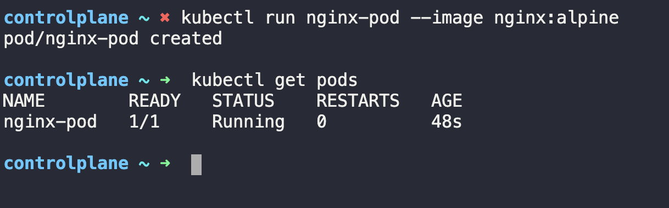

Deploy a redis pod using the redis:alpine image with the labels set to tier=db.

$ kubectl run redis --image redis:alpine -o yaml –dry-run=client > pod1.yaml

Then -🡪

vi pod1.yaml

metadata:

name: redis

labels:

tier: db

Then ---🡪 kubectl apply -f pod1.yaml

Create a service redis-service to expose the redis application within the cluster on port 6379. ---🡪 ClusterIP service

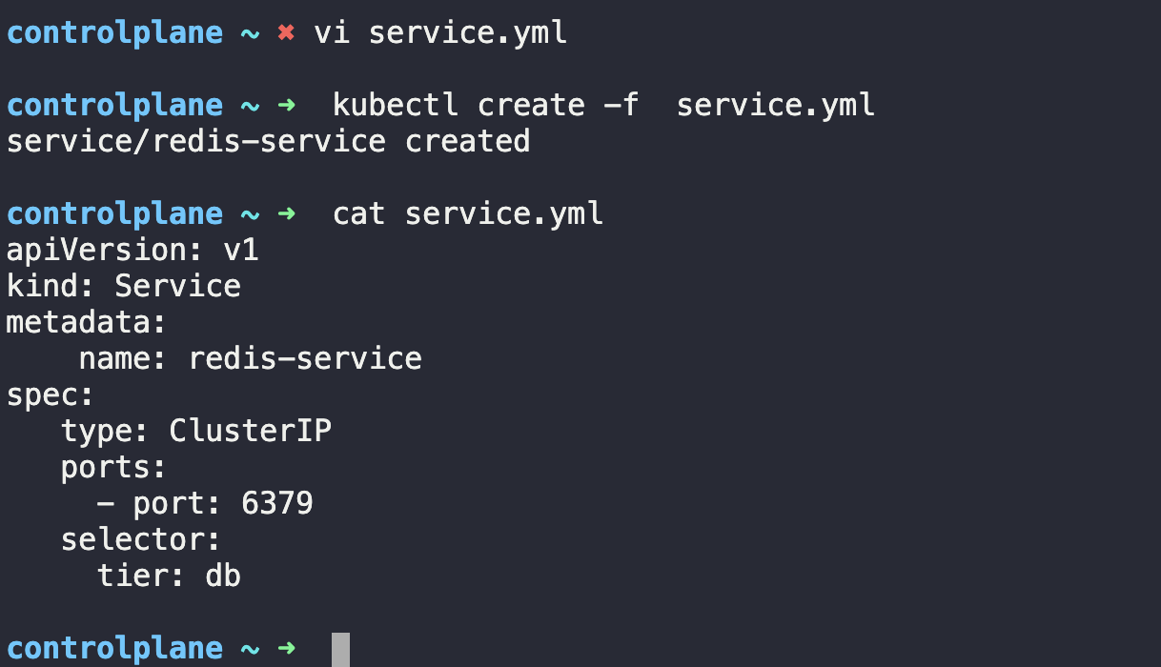

Create a deployment named webapp using the image kodekloud/webapp-color with 3 replicas.

Try to use imperative commands only. Do not create definition files.

$ kubectl create deployment webapp  --replicas=3 --image= kodekloud/webapp-color

Create a new deployment called redis-deploy in the dev-ns namespace with the redis image. It should have 2 replicas.

Use imperative commands.

$ kubectl create deployment redis-deploy  --namespace=redis-deploy  --image= redis  --replicas=2